**Pet Service Platform**

**Software Requirements Specification**

**01/06/2024**

**Prepared for**

**N1 - NET1804**

Table of Contents

I. Introduction 2

1.1 Purpose 2

1.2 Scope 2

1.3 Definitions, Acronyms, and Abbreviations 2

II. User Requirements 3

1. Actors 3

2. Use Cases 3

2.2 Descriptions 4

III. Functional Requirements 6

1. Context Diagram 6

2. Screen Flow 7

IV. Data Requirements 8

4.1 Logical Data Model 8

4.2 Front End Details 9

4.3 Technical Requirements (TRD) 11

# I. Introduction

In today’s fast-paced world, pet owners require a reliable and efficient platform to manage their pet care needs. The Pet Service Platform aims to address this need by providing a comprehensive online solution that facilitates the booking and management of various pet services. This Software Requirements Specification (SRS) document outlines the essential requirements and functionalities of the Pet Service Platform, serving as a guide for developers, testers, and stakeholders.

The platform is designed to cater to the diverse needs of pet owners, shop owners, and administrators, ensuring a seamless and user-friendly experience. By clearly defining the functional requirements, user interactions, and system behaviors, this document aims to ensure that the final product meets the highest standards of quality and reliability.

The purpose of this document is to provide a detailed description of the platform’s features, ensuring that all stakeholders have a clear understanding of the project’s scope and objectives. The scope of this SRS includes the essential functional requirements and user interactions, while non-functional aspects such as performance and stress testing are considered beyond its scope.

By adhering to the requirements specified in this document, the development team will be able to create a robust and efficient platform that meets the needs of all users and stakeholders involved.

## 1.1 Purpose

The purpose of this document is to outline the requirements for the Pet Service Platform, a comprehensive online system designed to streamline the process of booking and managing pet care services. This document serves as a reference for all stakeholders, including developers, testers, and end-users, ensuring a clear understanding of the platform's functionalities and requirements. It will guide the development process to ensure that the final product meets the needs of pet owners, shop owners, and administrators effectively.

## 1.2 Scope

The scope of this project encompasses the functional aspects of the Pet Service Platform. This includes detailed requirements for user interactions, data management, and system interfaces. The document specifies the features that will be tested to ensure they function as expected. Non-functional requirements such as performance testing, stress testing, and automation testing are not included in this scope. However, functional testing and validation of external interfaces are within the scope and will be thoroughly addressed to ensure a robust and user-friendly platform***.***

## 1.3 Definitions, Acronyms, and Abbreviations

|  |  |
| --- | --- |
| **Abbreviation** | **Word** |
| **G** | **Guest** |
| **C** | **Customer** |
| **S.O** | **Shop Owner** |
| **A** | **Admin** |

# II. User Requirements

## 1. Actors

|  |  |  |
| --- | --- | --- |
| **#** | **Actor** | **Description** |
| 1 | Customer | Individuals who own pets and utilize the pet care services offered by the platform. Pet owners are the primary users of the platform, seeking various services to ensure the well-being, health, and happiness of their pets. |
| 2 | Admin | Individuals responsible for maintaining and managing the pet care service platform. Administrators ensure the platform operates smoothly, securely, and efficiently while addressing user needs and optimizing the overall user experience. |
| 3 | Shop Owners | Shop Owners are businesses that sell pet-related products such as food, toys, accessories, grooming supplies, and other items. They use the platform to list their products, manage inventory, process orders, and interact with customers. |
| 4 | Guests | Guests are users who visit the platform to explore services and products without creating an account. They have limited interaction capabilities but can access information that helps them decide whether to register. |

## 2. Use Cases

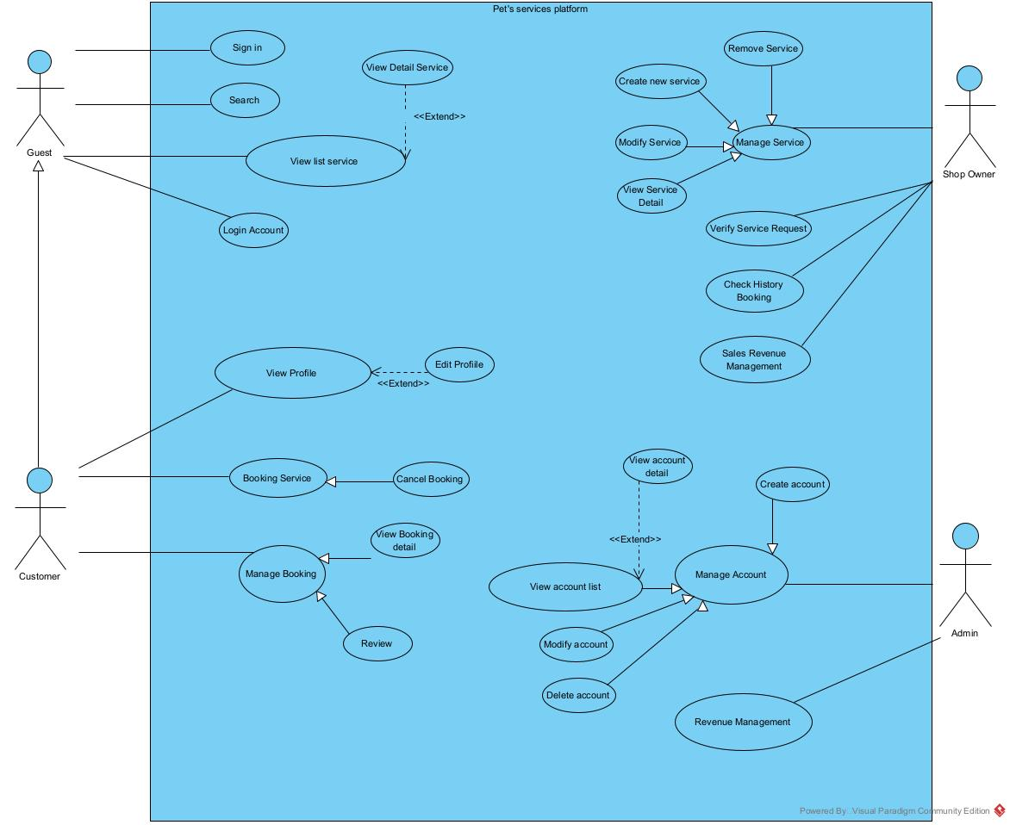

## 2.2 Descriptions

|  |  |  |
| --- | --- | --- |
| **Module Name (SR#)** | **Applicable Roles** | **Description** |
| **Sign in** | Guest | Guest: A guest can sign into the platform to access more features. |
| **Search** | Guest,Customer | Guest/Customer: A guest can search for available services on the platform. |
| **View List of Services** | Guest,Customer | Guest/Customer: A guest can view the list of all available services. |
| **View Detail Service** | Guest,Customer | Guest/Customer: A guest can view detailed information about a specific service. |
| **Login Account** | Guest | Guest: A guest can log into their account to access personalized features. |
| **View Profile** | Customer | Customer: A customer can view their profile details to see personal information and settings. |
| **Edit Profile** | Customer | Customer: A customer can edit their profile information to keep their details up-to-date. |
| **Booking Service** | Customer | Customer: A customer can book a specific service to schedule an appointment. |
| **Cancel Booking** | Customer | Customer: A customer can cancel a booking they have made to manage their appointments. |
| **View Booking Detail** | Customer | Customer: A customer can view details of their bookings to keep track of scheduled services. |
| **Manage Booking** | Customer | Customer: A customer can manage their service bookings to keep track of and modify appointments. |
| **Review** | Customer | Customer: A customer can leave a review for the services they have used to share their experience with others. |
| **Create New Service** | Shop Owner | Shop Owner: A shop owner can add a new service to the platform to offer more options to customers. |
| **Modify Service** | Shop Owner | Shop Owner: A shop owner can make changes to an existing service to keep service information current. |
| **Remove Service** | Shop Owner | Shop Owner: A shop owner can remove a service from the platform to stop offering it. |
| **Manage Service** | Shop Owner | Shop Owner: A shop owner can manage their services to keep track of and update them as needed. |
| **Verify Service Request** | Shop Owner | Shop Owner: A shop owner can handle and verify incoming service requests to provide services to customers. |
| **Check History Booking** | Shop Owner | Shop Owner: A shop owner can check the booking history to review past appointments and services provided. |
| **Sales Revenue Management** | Shop Owner, Admin | Shop Owner: A shop owner can view and manage revenue data related to their services.  Admin: An admin can oversee and manage revenue data for the entire platform. |
| **View Account List** | Admin | Admin: An admin can view a list of all user accounts to manage the platform's users. |
| **View Account Detail** | Admin | Admin: An admin can view detailed information of user accounts to manage user data effectively. |
| **Manage Account** | Admin | Admin: An admin can manage user accounts to keep user information accurate and up-to-date. |
| **Create Account** | Admin | Admin: An admin can create new user accounts to allow new users to join the platform. |
| **Modify Account** | Admin | Admin: An admin can make changes to user accounts to update user information as needed. |
| **Delete Account** | Admin | Admin: An admin can delete user accounts from the platform to remove inactive or inappropriate users. |
| **Revenue Management** | Admin | Admin: An admin can oversee and manage revenue data for the entire platform to ensure financial health and compliance. |
|  |  |  |

# III. Functional Requirements

## 1. Context Diagram

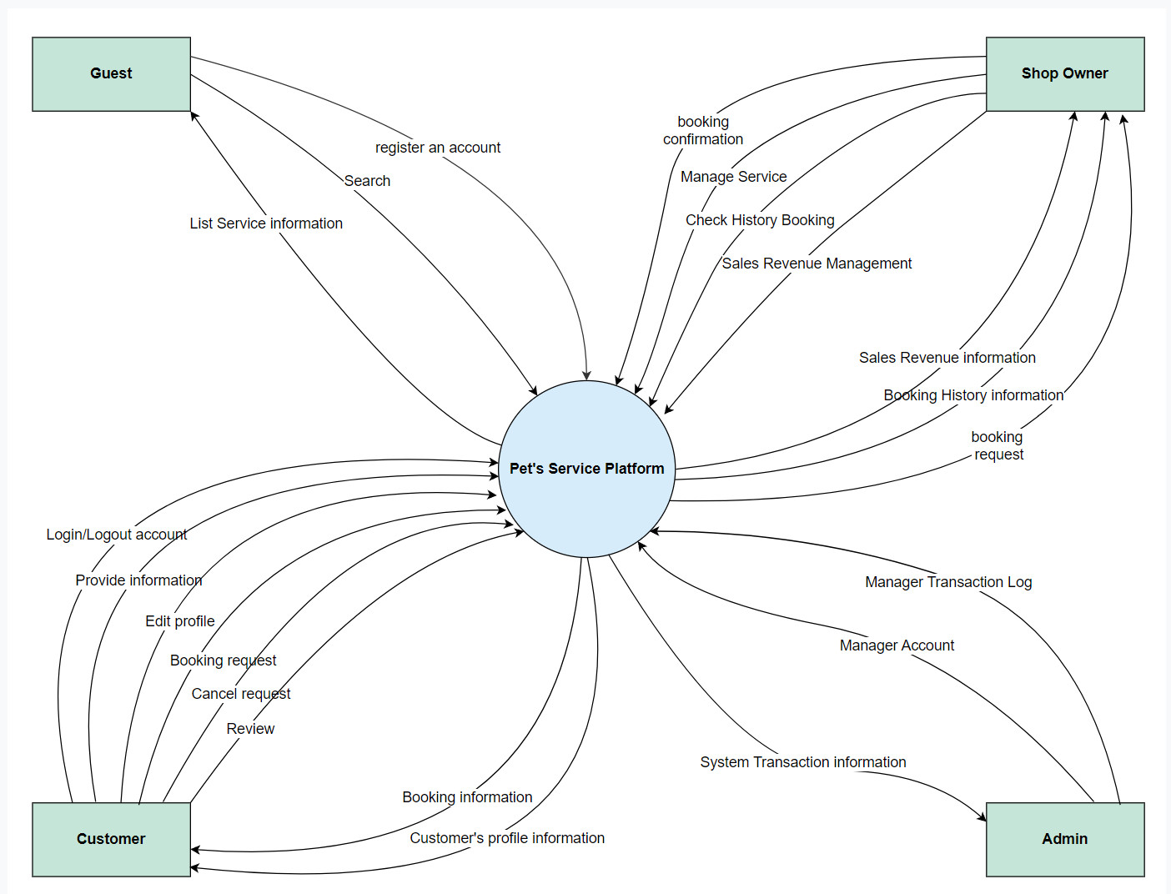

## 

## 2. Screen Flow

UI: User interface

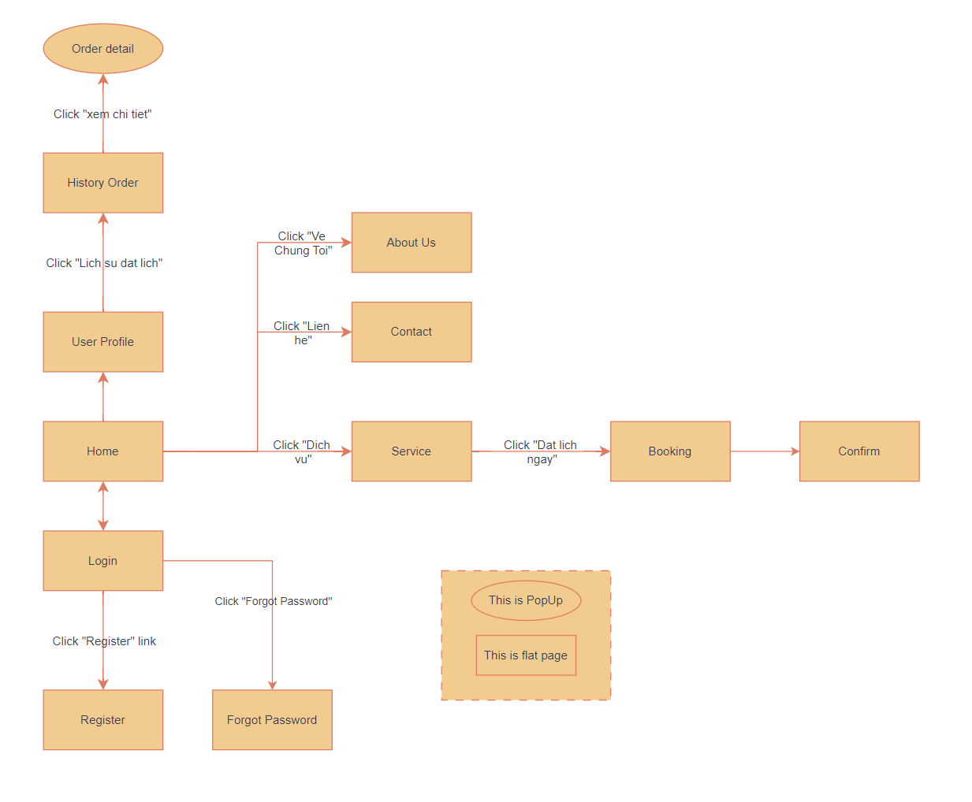

# IV. Data Requirements

## 4.1 Logical Data Model

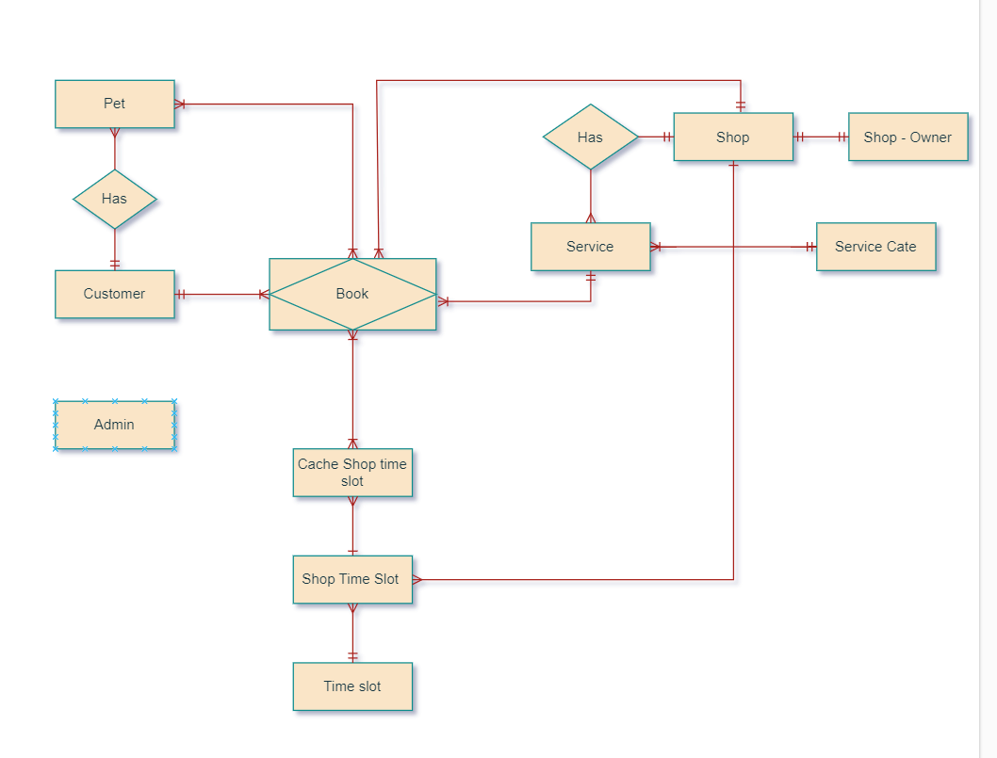

## 4.2 Front End Details

This section describes the Front end of Pet Spa

It also lists a few use cases to describe the functioning of the system

Following is a list of module wise fields

**New Customer**

* Email
* Password
* User Name
* Telephone Number
* Submit
* Reset

**Login**

* Email
* Password
* Submit
* Reset

**Booking Service**

* Pet Type
* Date
* Timeslot
* Name
* Weight
* Submit

**Change Password**

* Old Password:
* New Password:
* Submit

**Edit Account**

* Email
* Telephone Number
* Submit

**Create Service**

* Service Name
* Service Description
* Service Location
* Pricing Table
* Available Time Slots
* Submit

**Update Service**

* Service Name
* Service Description
* Service Location
* Pricing Table:
* Available Time Slots:
* Submit

**Delete Service**

* Service ID
* Confirm Deletion
* Submit

**Delete Account**

* Customer ID
* Submit

**Contact Form**

* User Name
* Phone Number
* Email ID
* Message
* Submit

## 4.3 Technical Requirements (TRD)

**New Customer**

**T1** Email - Email must not be blank

**T2** Email - Email is not valid

**T3** Email - First character cannot have space

**T4** Password - Password must not be blank

**T5** Password - Password must meet complexity requirements

**T6** User name – Numbers are not allowed

**T7** User name – Special characters are not allowed

**T8** User name – User name must not be blank

**T9** User name – First character cannot have space

**T10** Telephone Number – Mobile no must not be blank

**T11** Telephone Number  – Special character are not allowed

**T12** Telephone Number  – Character are not allowed

**T13** Telephone Number - First character can not have space

**Login**

**T14**   Email - Email must not be blank

**T15** Password - Password must not be blank

**Booking Service**

**T16**  Pet Type - Pet Type must be selected

**T17** Date - Date is required

**T18** Date - Date cannot be in the past

**T19**  Timeslot - Timeslot is required

**T20** Timeslot - Only one available timeslot is accepted

**T21** Name - Name must not be blank

**T22** Weight - Weight must not be blank

**T23** Weight - Pet weight should only contain numbers

**T24** Weight - Pet weight should not contain special characters

**T25** Weight - Pet weight should not start with a space

**Change Password**

**T26** Old Password must not be blank

**T27** New Password must not be blank

**T28** The new password must not be the same as the old password

**Edit Account**

**T29** Email - Email must not be blank

**T30** Email - Email is not valid

**T31** Email - First character can not have space

**T32** Telephone Number – Mobile no must not be blank

**T33**  Telephone Number  – Special character are not allowed

**T34** Telephone Number  – Character are not allowed

**T35** Telephone Number - First character can not have space

**Create Service**

**T36** Service Name must not be blank

**T37** Service Description must not be blank

**T38** Service Location must not be blank

**T39** Pricing Table must have at least one valid entry

**T40** Available Time Slots must not be blank

**T41** Select at least one time slot

**Update Service**

**T42** Service Name must not be blank

**T43** Service Description must not be blank

**T44** Service Location must not be blank

**T45** Pricing Table musthave at least one valid entry

**T46** Available Time Slots must not be blank

**T47** Select at least one time slot

**Delete Service**

**T48** Service ID must not be blank

**T49** Confirm deletion must be checked

**Delete Account**

**T50** Customer Id - Customer ID is required

**T51** Customer Id - Customer ID must exist in the system

**T52** Customer Id - Characters are not allowed

**T53** Customer Id - First character cannot have space

**Contact Form**

**T54** User name must not be blank

**T55** User name should not contain numbers

**T56** User name should not contain special characters

**T57** User name should not start with a space

**T58** Phone number must not be blank

**T59** Phone number should not contain special characters

**T60** Phone number should not contain alphabetic characters

**T61** Phone number should not start with a space

**T62** Email ID must not be blank

**T63** Email ID must be valid

**T64** Email ID should not start with a space

**T65** Message must not be blank